ECSE 318
Group 04 - Katherine Chen, Natan Lago, Christopher Mayembe
Saab
October 10, 2025

Lab 2
5.)

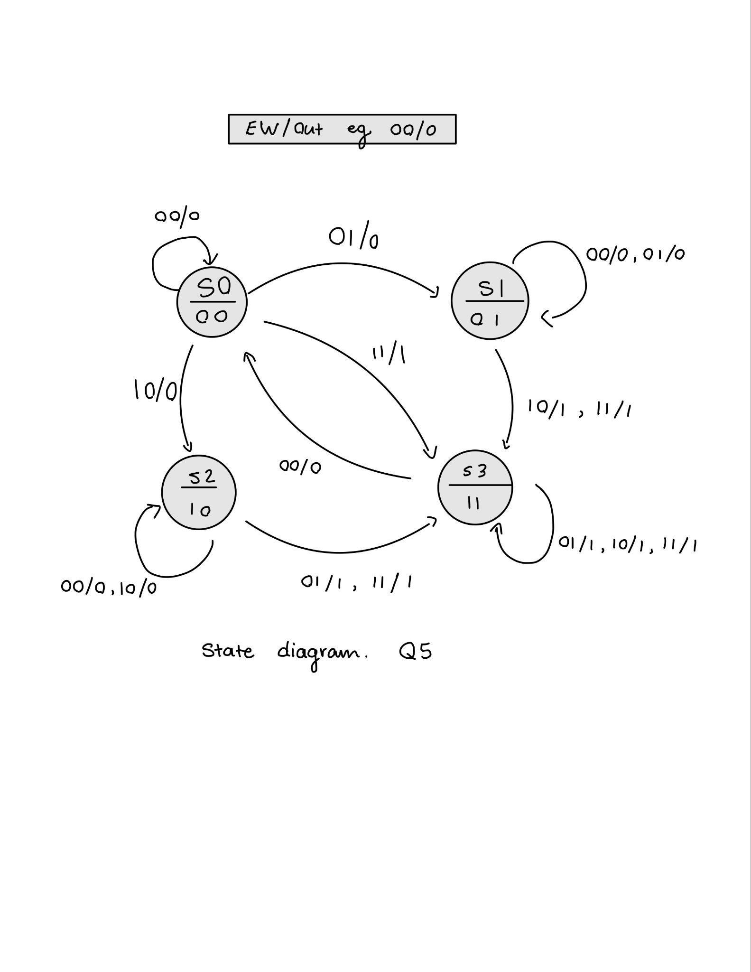

- Write a structural Verilog Model for and simulate your circuit to verify correctness. (Explain your approach)
  - The approach to developing the structural verilog model was to derive a truth table for the circuit. From there the sum of products was derived and used to create a k-map where the minimal sum was determined. This was done to determine an equation for the Qa and Qb values separately and then for the final output that utilizes the values for E, W, Qa, and Qb. The equations were implemented on the gate by gate basis. A separate d flip flop module was created to control the transitions from Qa → Qa next and Qb → Qb next.
- Write a behavioral Verilog model based on the derived state-diagram and simulate to verify correctness.
  - The approach was similar to the structural approach, where the equations for Qa next, Qb next, and the final output were determined. However these were implemented using assign statements rather than the gates. The dff module was used again to control the changes of the Q values.
- Using ModelSim, can you verify that the model in a) and c) are equivalent (Explain).
  - The model’s in A and B observe the same output response to the inputted testbench values.

